Sheet #471: Concurrent Lines and Centers of Triangles v.2.2
Concurrent lines are three or more lines that intersect at a point.
Point of concurrency | A point where three or more lines meet | Points of concurrency of a triangle | Triangle Centers | Theorems | More theorems  / Constructions
Bisector of an Angle | A ray or segment that divides an angle into two congruent adjacent angles | Angular Bisectors intersect at this point | Incenter  (I) | The point equidistant from the three sides of a triangle | The center of the incircle (the circle inscribed in the triangle)
Perpendicular Bisector of a segment | A line or ray (or segment) that is perpendicular to a (another) segment at its midpoint | Perpendicular Bisectors intersect at this point | Circumcenter  (C) | The point equidistant from the three vertices of a triangle | The center of the circumcircle (circle circumscribed about a triangle)
Altitude of a triangle | The perpendicular segment from a vertex to the line that contains the opposite side | Altitudes intersect at this point | Orthocenter  (H)
Median of a triangle | A segment from the vertex to the midpoint of the opposite side | Medians intersect at this point | Centroid, Geometric  (G) | The point that is 2/3 of the distance from each vertex to the midpoint of the opposite side | Point of balance of a triangle with uniform mass (center of mass or center of gravity)
Euler Line | The line that passes through the circumcenter, orthocenter, and centroid
Distance from a point to a line | The length of the perpendicular segment from the point to the line

Incenter | Circumcenter | Orthocenter | Centroid, Geometric | Euler Line
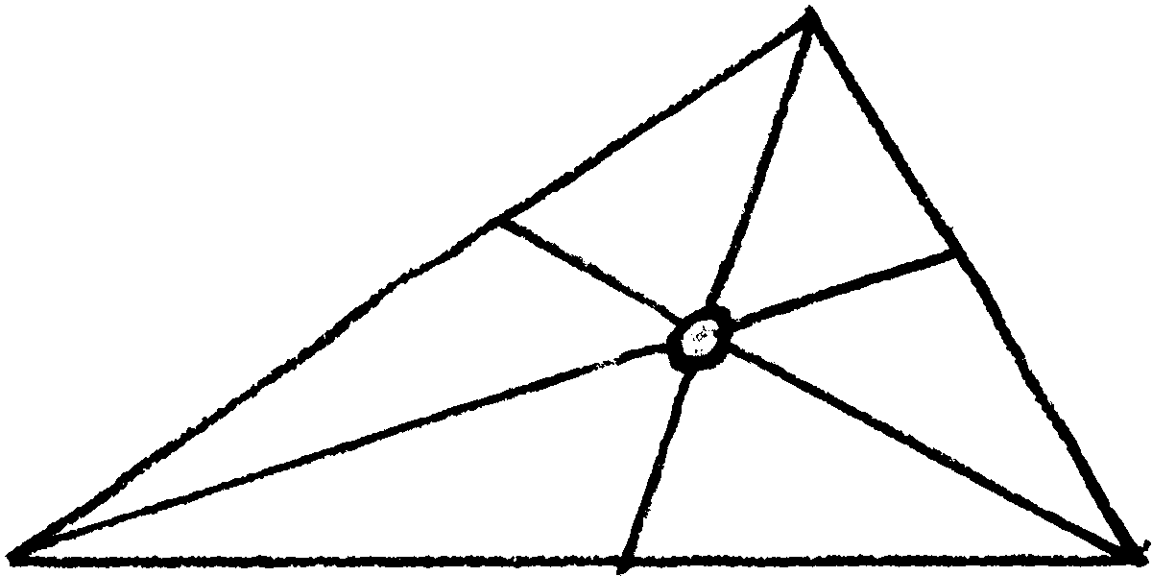 | 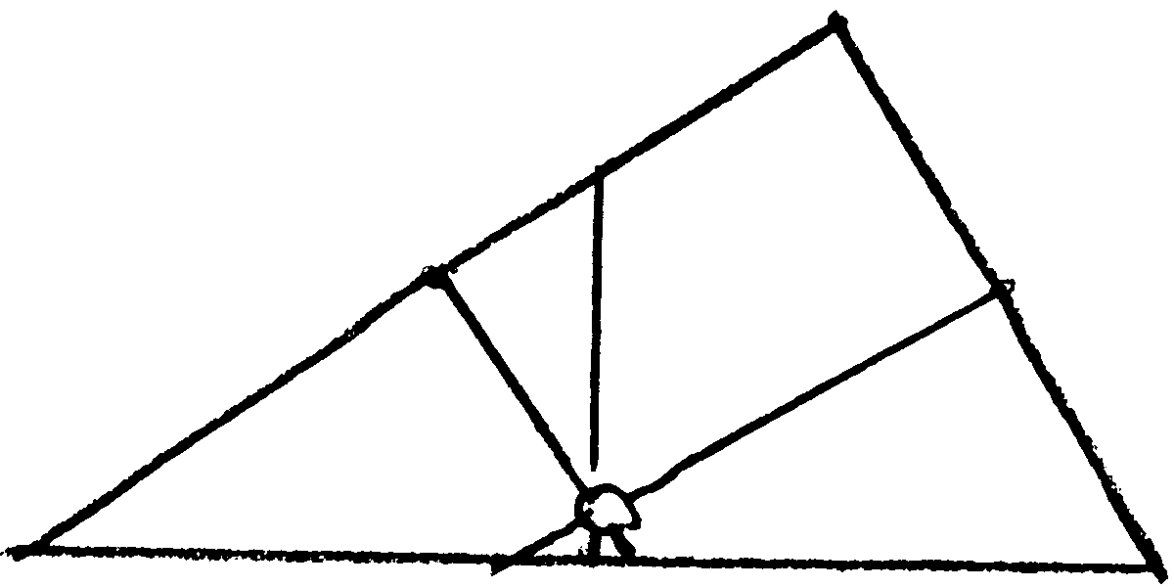 | 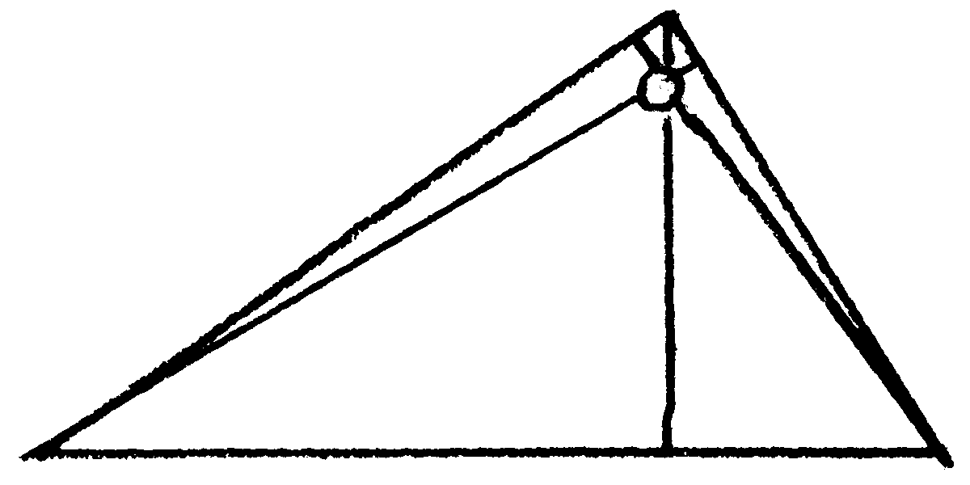 | 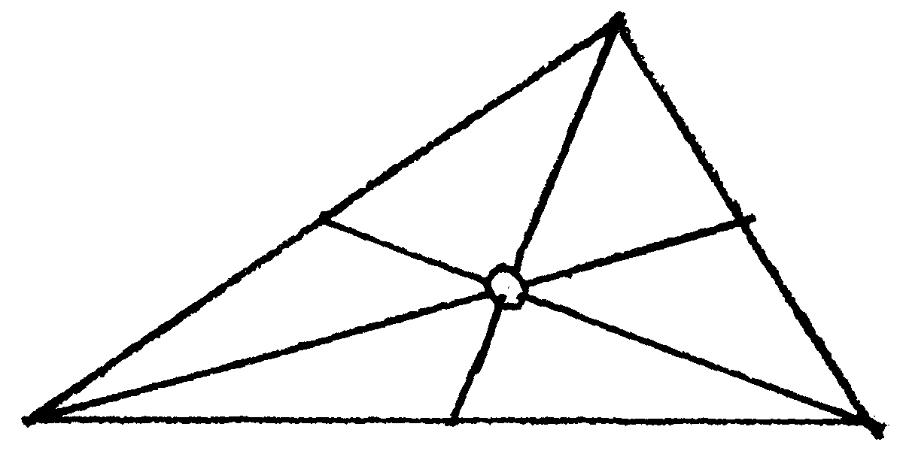 | 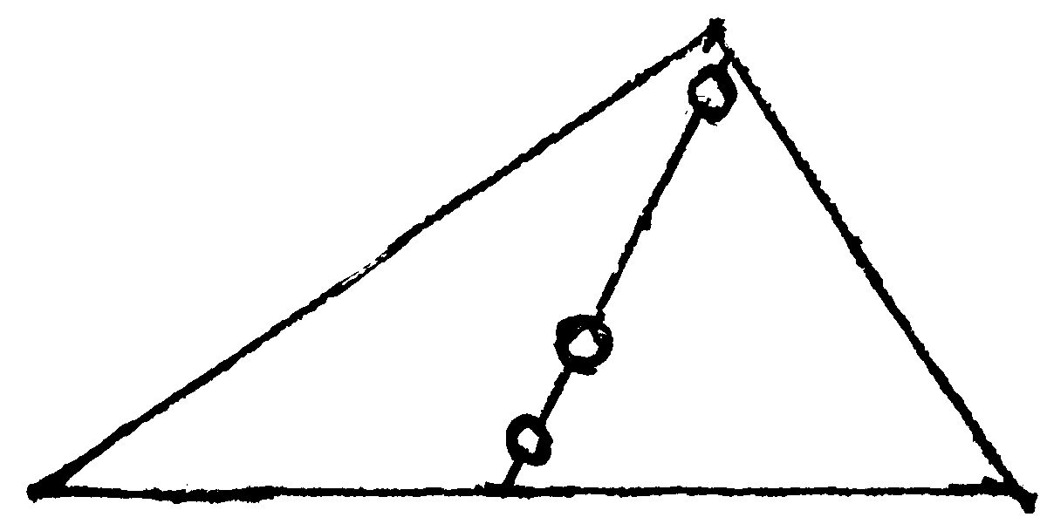

Bisector-Distance  Theorems | • A point is on the perpendicular bisector of a segment if and only if  it is equidistant from the endpoints of the segment.
Bisector-Distance  Theorems | • A point is on the bisector of an angle if and only if  it is equidistant from the sides of the angle.
• For isosceles triangles only, the Euler line passes through the incenter, circumcenter, orthocenter, and centroid (I, C, H, G). All four centers coincide in an equilateral triangle.
• The distance from the Centroid to the Circumcenter is 1/2 the distance from the Centroid to the Orthocenter.
• There are more than one hundred named triangle centers.
Sections 1.3 (p.13), 1.4 (p.19), 4.7 (pp.152-153), 10.3 (pp.386-387), 13.7 (p.556, Wr. Ex. 36-39).

