Sheet #473: Triangle Center study cards

Points of concurrency of a triangle | Triangle Centers | Theorems | More theorems  / Constructions | Figures
Angular Bisectors  intersect at this point | Incenter (I) | The point equidistant from the 3 sides of a triangle | The center of the  incircle | 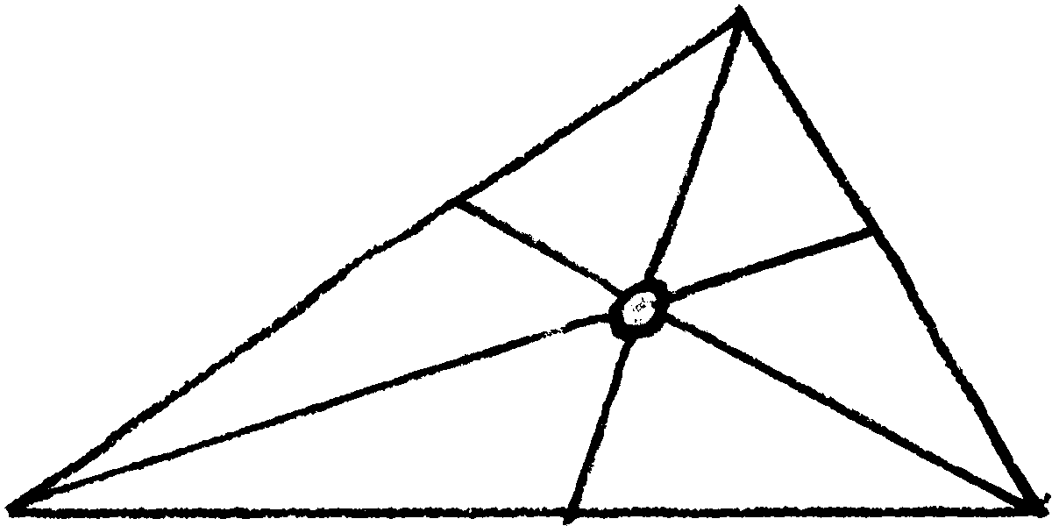
Perpendicular Bisectors intersect at this point | Circumcenter (C) | The point equidistant from the 3 vertices of a triangle | The center of the circumcircle | 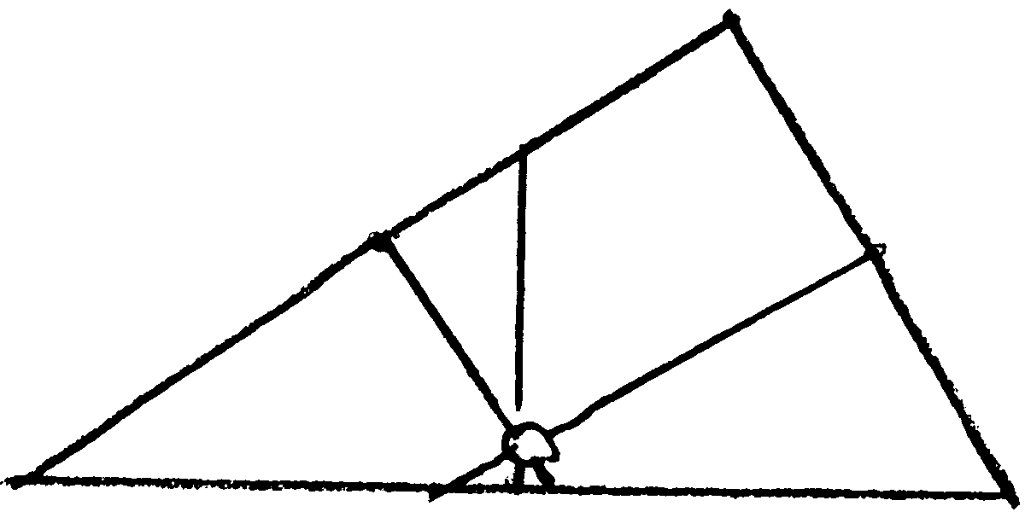
Altitudes  intersect at this point | Orthocenter (H) |  |  | 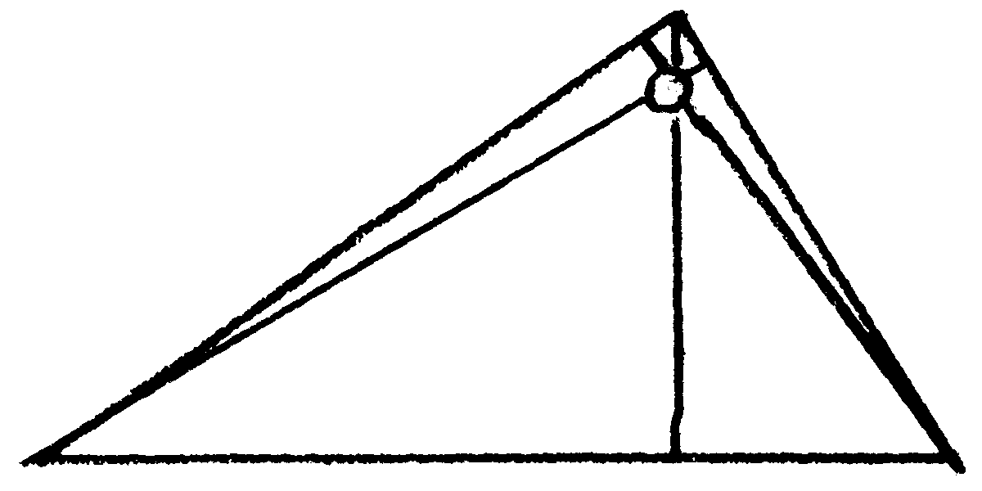
Medians  intersect at this point | Centroid (G) | The point that is 2/3 of the distance from each vertex to the midpoint of the opposite side | Point of balance of a triangle with uniform mass | 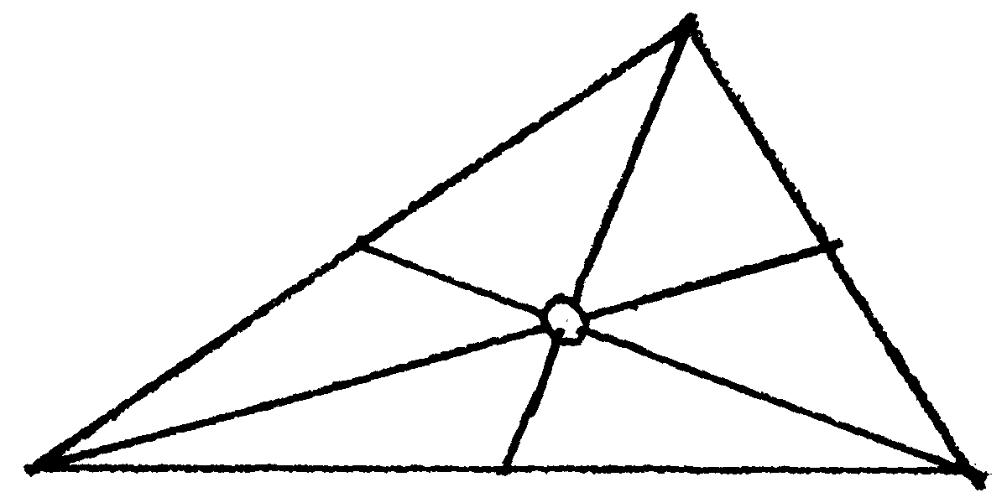
 | Euler Line | The line that passes through the circumcenter, orthocenter, and centroid |  | 